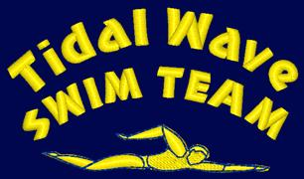
TIDAL WAVE SWIM TEAM
STROKE DEVELOPMENT CAMP - SUMMER 2018 REGISTRATION FORM

NAME OF SWIMMER(S):______________________________________________________
NAME OF PARENT: __________________________________________________________

Half Day $150 per week

MUST BE RETURNED TO POOL OFFICE, REGISTRATION SPACE IS LIMITED, BOOK EARLY!!!!!

Weeks: 1 – 5 for 14 and Under (TYM ADV and Lower)
Weeks: 6 – 9 Broken up into 11 and under and 12 and over (Or head coaches Discretion)
The above named swimmer(s) will attend the following week(s):

WEEK STROKE HALF DAY
1. June 25 – June 29 | Freestyle
2. July 2 - July 6 | Starts & Turns, Finishes | $130.00
3. July 9 - July 13 | Backstroke
4. July 16- July 20 | Breaststroke
5. July 13 - July 27 | Butterfly
6. July 30 – August 3 | Freestyle/Backstroke
7. August 6 - August 10 | Breaststroke/Butterfly
8. August 13 - August 17 | Starts & Turns, Finishes
9. August 20 - August 24 | Individual Medley TBA
I will attend every week
AGES 7-18

Non-TWST swimmers must be interviewed and evaluated by the coaching staff prior to registration. Please submit this form to the Front Desk, along with all other registration forms required by the Front Desk. Payments must be made by the Wednesday before the start of the desired week. Acceptable payment methods: automatic & manual credit card transactions, cash, check payable to the Boys & Girls Clubs of Union County

