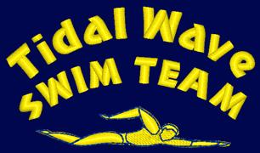
TIDAL WAVE SWIM TEAM
STROKE DEVELOPMENT CAMP - SUMMER 2022 REGISTRATION FORM

NAME OF SWIMMER(S):______________________________________________________
NAME OF PARENT: __________________________________________________________

Half Day $250 per week

MUST BE RETURNED TO POOL OFFICE, REGISTRATION SPACE IS LIMITED, BOOK EARLY!!!!!
Session 1-5 will be run next door (outdoor Knights of Columbus pool as our pool is still under construction

WEEK STROKE HALF DAY
1. June 27 – July 1 | Freestyle
2. July 5 - July 8 | Starts & Turns, Finishes | $200.00
3. July 11 - July 15 | Backstroke
4. July 18- July 22 | Breaststroke
5. July 25 - July 29 * | Butterfly
6. August 1 – August 5 | Freestyle/Backstroke
7. August 8 - August 12 | Breaststroke/Butterfly
8. August 15 - August 19 | Starts & Turns, Finishes
9. August 22 - August 26 | Individual Medley
I will attend every week
AGES 7-18

Non-TWST swimmers must be interviewed and evaluated by the coaching staff prior to registration. Please submit this form to the Front Desk, along with all other registration forms required by the Front Desk. Payments must be made by the Wednesday before the start of the desired week. Acceptable payment methods: automatic & manual credit card transactions, cash, check payable to the Boys & Girls Clubs of Union County

