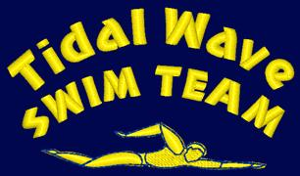
TIDAL WAVE SWIM TEAM
STROKE DEVELOPMENT CAMP - SUMMER 2023
REGISTRATION FORM

NAME OF SWIMMER(S):______________________________________________________
NAME OF PARENT: __________________________________________________________

Half Day $300 per week

MUST BE RETURNED TO POOL OFFICE, REGISTRATION SPACE IS LIMITED, BOOK EARLY!!!!!

WEEK STROKE HALF DAY
1. June 26 – June 30 | Freestyle
2. July 3 - July 7 | Starts & Turns, Finishes | $250.00
3. July 10 - July 14 | Backstroke
4. July 17- July 21 | Breaststroke
5. July 24 - July 28 | Butterfly
6. July 31 – August 4 | Freestyle/Backstroke
7. August 7 - August 11 | Breaststroke/Butterfly
8. August 14 - August 18 | Starts & Turns, Finishes
9. August 21 - August 25 | Individual Medley
I will attend every week
AGES 7-18

Non-TWST swimmers must be interviewed and evaluated by the coaching staff prior to registration. Please submit this form to the Front Desk, along with all other registration forms required by the Front Desk. Payments must be made by the Wednesday before the start of the desired week. Acceptable payment methods: automatic & manual credit card transactions, cash, check payable to the Boys & Girls Clubs of Union County

