**ATTENTION TWST MEMBERS**

**Everyone should be preparing for the upcoming season. Remember,**

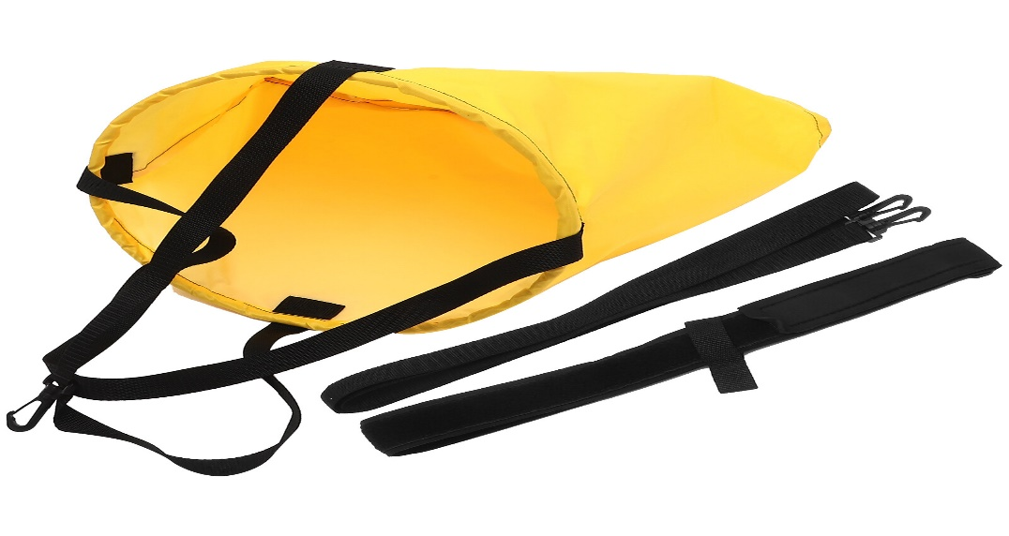**practice is VERY IMPORTANT to achieve your goal.**

KNOW WHAT WEAR HOW DO BEAST OF YOUR ABILITY

**• Set up your goals based on your best time.**

**• Manage your time. Make sure that you are doing well in school.**

**• Be prepared for each and every practice/meet. List of Gear for WALMART**

**Swimmers:**

TYM: Pull Buoy (ANKLE STRAP), Kick Board, Flippers. Paddles (Small). Mesh Bag 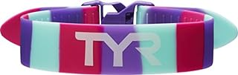 AMAZON SWIM OUTLET

Team Uniform

Junior/Senior: Pull Buoy (ANKLE STRAP) Kick Board Paddles (Juniors – Small/Medium) (Senior – Small/Large) Team GEAR: Flippers (Rubber FLIPPERS). Mesh Rate Watch Drag Suit Parachutes Recommended Uniform: T-Shirts, Shirt, Sweatshirt/Hoodie Sweatpants